**U01E04 – Php Scripts - II**

Make the following scripts using html and php.

For these scripts that are simple, you paste the code directly after the statement.

1. Develop a php script to:

You should have a variable con 50 numbers from 1 to 100.

* 1. Calculate the arithmetic average of an array of numbers.

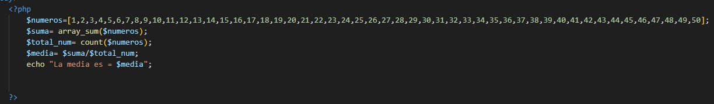

* 1. Calculate the arithmetic average of an array of numbers excluding the odd numbers.

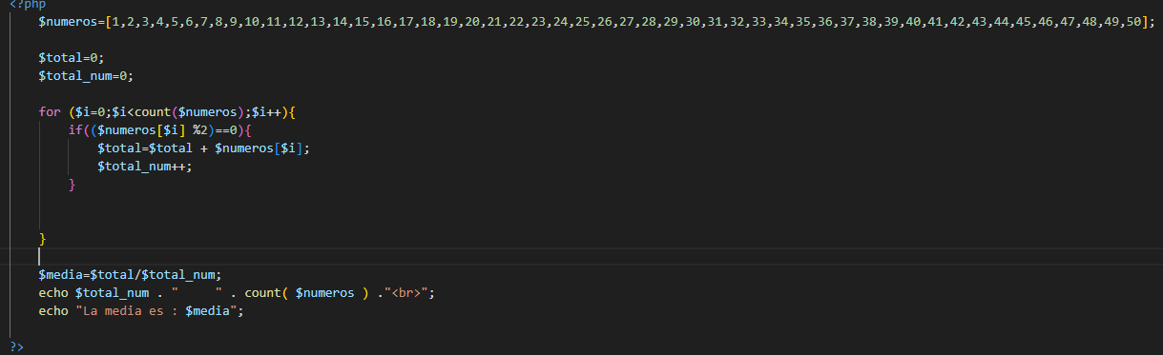

* 1. Calculate the arithmetic average of an array of numbers excluding the numbers that are in an odd position in the array.

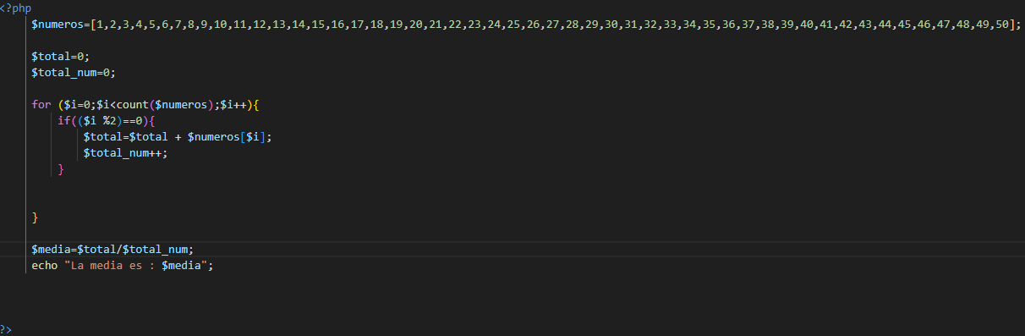

* 1. Declare a variable with a number between 1 and 10,000 and say how many digits it has.

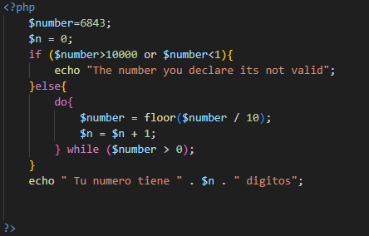

* 1. Read a number and display its square, repeat the process until a number is entered negative.

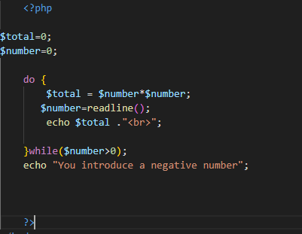

* 1. Prompt for numbers until a 0 is typed, display the sum of all numbers entered.

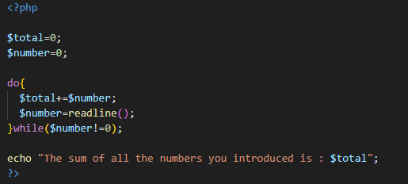

* 1. Ask for numbers until a negative one is entered, and calculate the average.

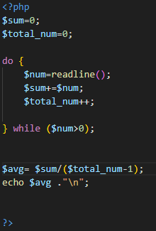

* 1. With an array of numbers. Show the average of the positive numbers, the average of the negative numbers and the number of zeros.

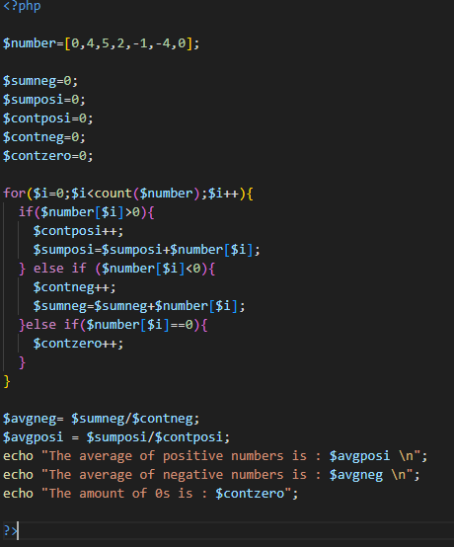

* 1. Ask for a number (which must be between 0 and 10) and show the multiplication table for that number.

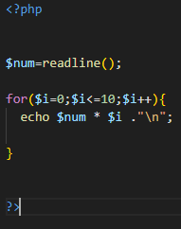

* 1. Design an application that shows the multiplication tables from 1 to 10.

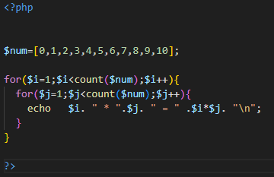

* 1. Draw a square of n elements on each side using *.

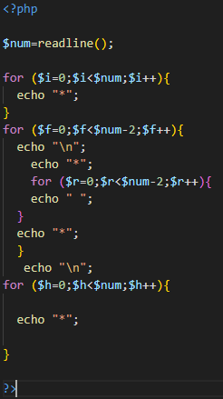

* 1. Create a program that asks us for a number n, and tells us how many numbers there are between 1 and n that are prime numbers.

